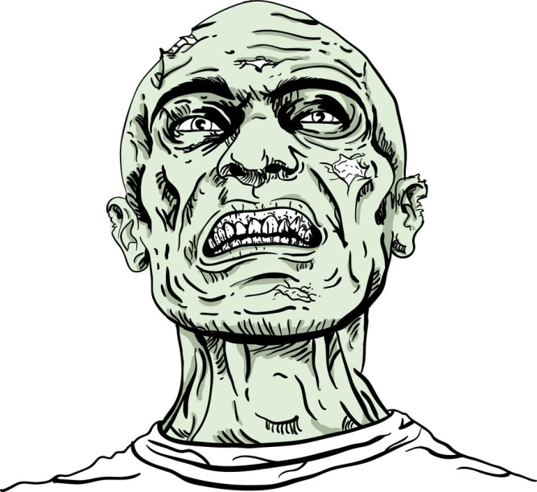
Haunted Range
Zombie Shoot RULES
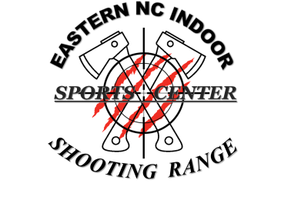
Operation Black Out (Div. 1)

Shooter: Must be 21y/o
12 y/o & up with an adult (21yo) spotter.
Spotter: Must be 12 y/o and up.

DIVISION-1: Operation Black Out
- Must bring your Personal Handgun with side holster and 20 Bullets. (40 caliber or less allowed)
- Gun rentals available
- ENC Indoor Shooting Range AR-15 rifle will be optional in this division (course).
(ENC Shooting Range will provide rifle and rifle bullets for you at no extra cost).
- Beginner shooters and up Only (No new shooters)

Spotter, (Friend). A friend or family member may accompany you in the shoot but they cannot shoot and you must make sure they are safely behind you without being captured or touched by a zombie. The spotter must remain behind the shooter at all times. Spotter, you must rely on the shooter to get you through the course without harm. A spotter may take pictures and/or videos as long as it does not distract the shooter. A spotter must be 12 y/o or older.

HOLSTERS MUST BE USED:
- Any safe side holster that is not a cross draw, back holster, or shoulder or shoulder rig. Side holster only.
- LEO/MIL may use thigh rigs or duty gear.
- AMMO: Bring 20 bullets. Absolutely no bullets in your possession when starting the course. Our staff will collect your bullets and place them in the course ammo loading stations. It’s up to you to get to each loading station without being eaten by a zombie. Once again, no bullets will be carried anywhere on your body or the spotters body while running the course.
- Extra magazines are not needed in this division

AMMO LOADING STATIONS: (Green Glow Box)
The zombie live shoot ammo loading stations are small glow boxes you must get to and load your gun. Getting to an Ammo loading Station is your objective. You must safely get to your loading station, load your weapon and engage your target. One you start loading your weapon the zombies will come to life. Once you run dry (run out of ammo) you must move to the next load station, load, and engage your next target.
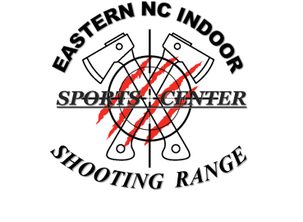
TARGETS:

1) All Zombie targets need at least one (1) head shot to kill and incur no penalty.
2) A head shot is not required for non-Zombie targets, such as a gunman holding hostages.
3) A penalty will be given for each victim target shot.
4) No target should be shot at point blank range within five feet of the shooter or spotter. A penalty will incur.
5) This course is designed for fun, scary and not hard. Safety issues will be addressed immediately and disqualification to run the course will incur.
SCORING:
All targets are provided by ENC Indoor Shooting Range. A staff member will give you one target to take home for bragging rights and to show-off to friends and family.

1) All Zombie head shots are 10 points (10-pts.) each.
2) Non Zombie threat targets are 10 points (10-pts.) each. A head shot is not required for non-Zombie targets, such as man holding hostages.
3) One point (1-pt.) penalty will be giving for each victim target shot.
4) One point (1-pt.) penalty will be given for each target shot closer than 5 feet.
5) Five point (5 pts) penalty if a spotter distracts the shooter while engaging a target.
6) This division is not timed.
Total score you can obtain: 200 points.

RANGE COMMANDS
- ARE YOU READY: shooter will state when he/she is ready to start stage
- MAKE READY: Shooter will load his gun at the loading station and engage target.
- STANDBY: Delay to start signal
- STOP: shooter will IMMEDIATELY CEASE FIRE, FINGER OFF TRIGGER, MUZZLE IN SAFE DIRECTION, and AWAIT FURTHER COMMAND.
- FINGER: Remove finger from inside trigger guard while loading, unloading, moving.
- MUZZLE: Always pointed in a safe direction.
- UNLOAD AND SHOW CLEAR: shooter removes magazine/opens cylinder, unloads before moving to the next ammo station or lane.
- MOVE: Shooter and Spotter may move to the next stage.
- RANGE IS CLEAR: May go forward to score/ paste / reset targets

Prices:
Shooter: $20.00 (max, one shooter)
Spotter: $5.00 (max, one spotter)
Gun Rentals available for $15.00 (Ammo Included)
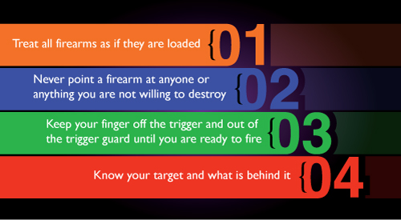SAFETY IS OUR : 1ST PRIORITY

Be safe and have fun ,,, come back again
For questions about the Zombie Shooting Event contact us at:
EMAIL at: ENCSPORTSCENTER@GMAIL.COM or Call us: 252-977-9878

